A000-AM,C-Taino-Cemi-Maquetaurie Guava-Lord of the Dead-Conch Shell-1000 CE

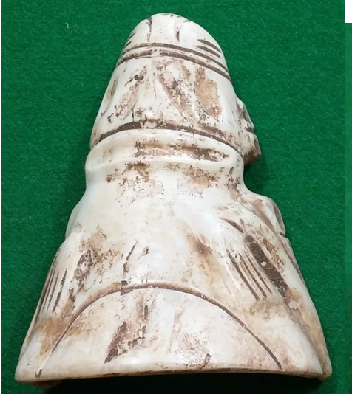 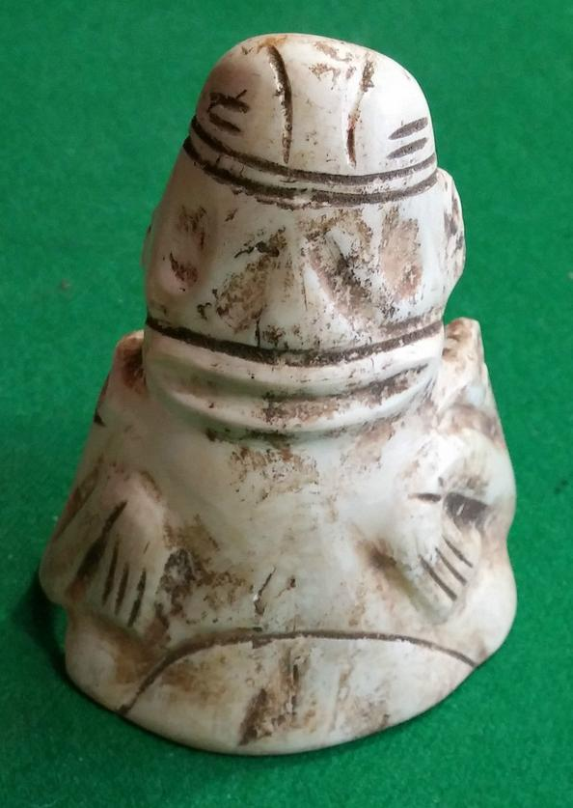

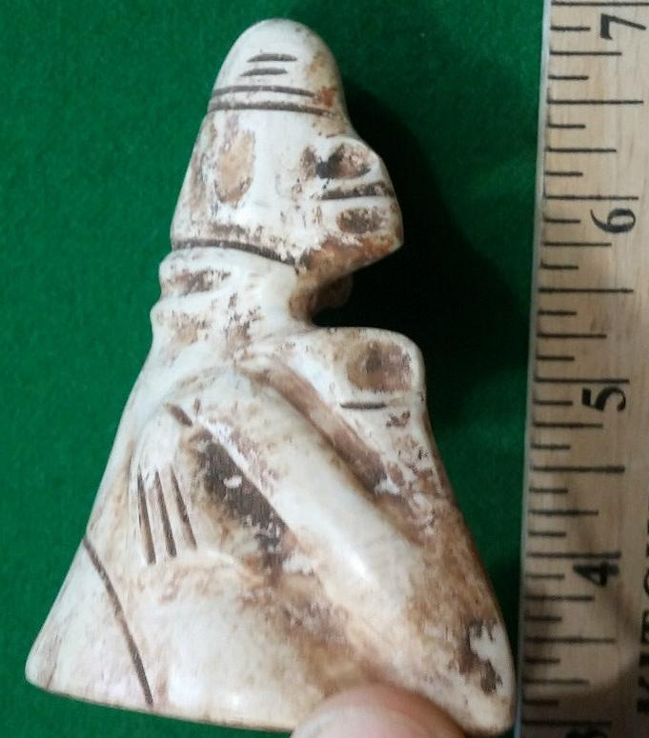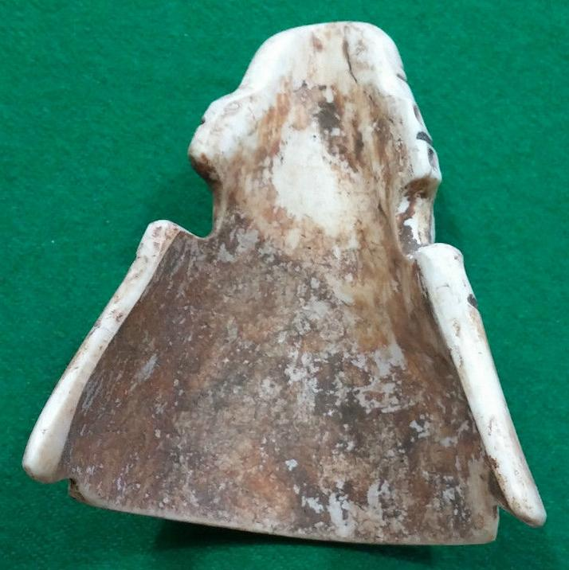

Figs. 1-3. AM,C-Taino-Cemi-Maquetaurie Guava-Lord of the Dead-Conch Shell-1000 CE

Case No.: 18

**Accession No.**

**Formal Label:** AM,C-Taino-Cemi-Maquetaurie Guava-Lord of the Dead-Conch Shell-1000 CE

**Display Description:**

This depiction of Maquetaurie Guava-Lord of the Dead-as a truncated individual indicates the robes traditionally worn by such personages. Significant also is his headgear which appears like an “overseas cap” with a central ridge framed by two flat near vertical borders. The use of Maquetaurie Guava-is also significant metaphorically, since one has to die to one’s present self in order to experience a true *metanoia* with the effects of *cohoba.* So, here is Maquetaurie Guava to act as a psychopomp to help us on our way.

Taíno cosmology, religion and its rituals is described in Fray Ramón Pané’s *An Account of the Antiquities of the Indians*, the most important anthropological document on the Taíno that contains a wealth of information on this extinct culture. His commission from Columbus required him to record the Taíno beliefs and ceremonies as accurately as possible, and to that end he lived among the native Taíno population from 1493 to 1498. However, he was also a product of fifteenth century Roman Catholicism, and his primary goal was to convert the Taínos whom he regarded as heathens and idolaters. “[Some] were inclined to believe easily. But with others there is need for force and ingenuity because we are not all made of the same stuff. Although those people made a good beginning and a better end, there will be others who will begin well and afterwards will laugh at what has been taught them; with them there is need for force and punishment” (Pané p. 38).

The Tainos believed that the dead went to Coaybay ( "abode of the absent") at the end of an island called Soraya. A place in the distance, inaccessible to the living, governed by [Maquetaurie Guava](https://translate.googleusercontent.com/translate_c?depth=1&hl=en&prev=search&rurl=translate.google.com&sl=es&u=http://pueblosoriginarios.com/centro/antillas/taino/maque.html&usg=ALkJrhjPHXvKfHZkwRcHGDMcxmwHjzZ-Zw) ; It is an independent space with an independent leader. Opias (or hupias ) - spirits of the dead, who like Opiyelguobirán are irreverent and mocking - enjoy cheating the living.They sleep during the day and go out at night to eat guava, whose juice produces a black paint with which they symbolized death.

Maquetaurie Guava’s function was to maintain the balance between the antagonistic forces of the day (order, world of the living) and night (disorder, world of the dead).

The lord of the dead

"Dog fasting, abstinence guava". He is the lord of Coaybay - "Abode of the absent" in the region of Soraya-, responsible for manter guard and watch the rest of the space where absent.

The opy (or hupías)-spirits of the dead, which like Opiyel Guobirán are irreverent and mocking, they enjoy deceive living. They sleep during the day and come out at night to eat guava juice which produces a black paint with which symbolize death.

Its function was to maintain the balance between the opposing forces of the day (order of the living) and night (disorder, world of the dead).

So says [Ramon Pane](https://translate.googleusercontent.com/translate_c?depth=1&hl=en&prev=search&rurl=translate.google.com&sl=es&u=http://pueblosoriginarios.com/biografias/pane.html&usg=ALkJrhj93Q1oq79G5oFuYQsZQlAOSsmzgA) , in Chapters 12 and 13 ["Relation about the antiques of the Indians"](https://translate.googleusercontent.com/translate_c?depth=1&hl=en&prev=search&rurl=translate.google.com&sl=es&u=http://pueblosoriginarios.com/textos/pane/3.html&usg=ALkJrhhndrqPsArDfEL5jUZ4n7MdKrmFUA) (after http://pueblosoriginarios.com/centro/antillas/taino/maque.html):

Chapter 12:

"They think there is a place to go dead, called Coaibai, which is at one end of the island, called Soraya. The first one was in the Coaibai say it was one called Maquetaurie Guava, who was lord of Coaibai, room house and the dead. "

Chapter 13:

"They say that during the day the dead are held;. At night will break and eat some fruit called guabaza, flavored with ... that day are ... [locked] At night, they become in fruit, they have their playground, and they together with the living for the dead are as follows:. that hand will touch the belly, and if they find the navel say it is operito, meaning dead, they say that the dead have no navel, and so is sometimes deceiving, because there noticing this, lie with a woman of the Coaibai, and when they think hug, they have nothing, because suddenly disappears this is what they think today. . about this long as a person Goeiz call the soul lives, and after the call opia dead, the Goeiz say it often appears, and as a man or as a woman, and say there has been man who dared to fight a Goeiz, and wanting to embrace it, it disappeared and Indian arms got away, over some trees, which was hung. This I believe everyone in general, as small than their elders, and they are dead appear as father, mother, brothers, relatives, or other forms. The fruit of that claim eating the dead, is the size of a peach. The dead are not displayed by day, but always at night, and therefore, not without great fear some Indian dares to go alone at night. "

**Dimensions: W 3 in x H 3 7/8 in**

This Taino cemi features Maquetaurie Guava-Lord of the Dead- with his exposed lipless mouth, i

**LC Classification: F 1909**

**Date or Time Horizon: 1000 CE**

**Geographical Area:** From Eastern Hispaniola, i.e., the Dominican Republic

**Map:**

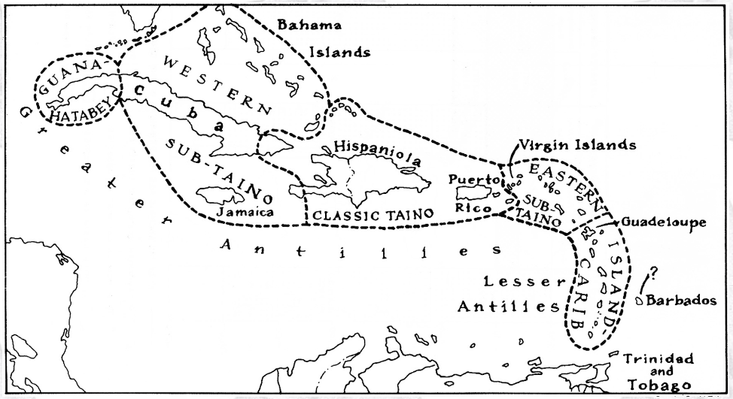

Caribbean c 1500 after http://www.latinamericanstudies.org/maps/Ciboney-Taino-Carib-

**GPS coordinates:**

**Cultural Affiliation:** Classic Taino

**Medium:** Manatee rib

**Dimensions:** Length 7.9 cm. or 3.1 in.

**Weight:**

**Condition:** original, intact

**Provenance:** From Eastern Hispaniola, i.e., the Dominican Republic

**Discussion:**

Since this cemi has a “V” shape, it is possible that this was going to be drilled to act as a *cohoba* inhaler.

Pané was a Catalan a Hieronymite monk of the Order of St. Jerome. These hermit monks lived according to the Rule of Saint Augustine, which stresses chastity, poverty, obedience, worldly detachment, physical labor, fraternal charity, common prayer, fasting and abstinence. Saint Jerome, a fifth-century hermit and biblical scholar, formulated the rules of the order. In the eyes of the Spanish church hierarchy, Pané was a poor Hieronymite hermit, a Catalan peasant not of Castilian origins and was dismissed probably for these social reasons by the Spanish Dominican Bartolomé de Las Casas (ca. 1484– 18 July 1566) as a “simple man” with “limited faculties” (Pané p. 57), whose efforts, “amounted to nothing more than to say the Ave María and Pater Noster to the Indians, and some words about there being a God in heaven who was the creator of things, according to what he was able to teach them with abundant flaws and in a muddled way” (Pané p. 57). However derogatory Las Casas’ criticisms of Pané are, Pané’s *Account* is still the best source of information on the Taíno.

**References:**

Callaghan, R. T.

1990 Possible Pre-ceramic Connections between Central America and the Greater Antilles. Proceedings of the Eleventh Congress of the International Association for Caribbean Archaeology,

1985, pp. 65-71, Puerto Rico.

1991 Passage to the Greater Antilles: An Analysis of Watercraft and the Marine Environment. Proceedings of the Fourteenth Congress of the International Association for Caribbean Archaeology, 1989, pp. 64-72, Barbados

Coe, W. R., II

1957 A Distinctive Artifact Common to Haiti and Central America. American Antiquity 22:280-282.

Cruxent, J. M., and I. Rouse

1969 Early Man in the West Indies. Scientific American 221(5):42-52.

Dacal, Ramon and Manuel R. de la Calle. 1986: Aboriginal Archaeology of Cuba, editorial New People, p.149. Havana, Cuba.

Gerrell, P. R., J. F. Scarry, and J. S. Dunbar

1991 Analysis of Early Archaic Unifacial Adzes from North Florida. The Florida Archaeologist 44(1):3-16.

Giménez Fernández, Manuel (1971). "Fray Bartolomé de Las Casas: A Biographical Sketch". In Friede, Juan; Keen, Benjamin (eds). Bartolomé de las Casas in History: Toward an Understanding of the Man and his Work. Collection spéciale: CER. DeKalb: Northern Illinois University Press. pp. 67–126.

Hester, T. R.

1994a An Introduction to the Colha Preceramic Project.

Paper presented at the 59th Annual Meeting of the Society for American Archaeology, Anaheim.

1994b The Archaeological Investigations of the Colha Project, 1983 and 1984. In Continuing Archaeology at Colha, Belize, edited by T. R. Hester, H. J. Shafer, and J. D. Eaton, pp. 1-9. Texas Archaeological Research Laboratory, University of Texas, Austin.

Hester, T. R., H. J. Shafer, and T. C. Kelly

1980 A Preliminary Note on Artifacts from Lowe Ranch:

A Preceramic Site in Belize. In The Colha Project Second Season, 1980 Interim Report, edited by T. R.

Hester, J. D. Eaton, and H. J. Shafer.

1992. Center for Archaeological Research, University of Texas, San Antonio, and Centro Studi Ricerche Ligabue, Venezia. San Antonio.

Hester, T. R., H. Iceland, D. Hudler, R. Brewington, H. J. Shafer, and J. Lohse

1993 New Evidence on the Preceramic Era in Northern Belize: A Preliminary Overview. The Newsletter of the Friends of the Texas Archeological Research Laboratory 1(2): 19-23.

Hester, T. R., H. Iceland, D. Hudler, and H. J. Shafer

1996 The Colha Preceramic Project. Mexicon XVIII (3): 50.

Hudler, D. B., T. R. Hester, and H. B. Iceland

1995 The Colha Preceramic Project: A Status Report.

Paper presented at the 60th Annual Meeting of the Society for American Archaeology, Minneapolis.

Iceland, H. B., and T. R. Hester

1996a The Colha Preceramic Project: A Status Report.

Paper presented at the 61st Annual Meeting of the Society for American Archaeology, New Orleans.

1996b The Earliest Maya? Origins of Sedentism and Agriculture in the Maya Lowlands. Preprints of the XIII International Congress of the Prehistoric and Protohistoric Sciences, Forli, Italy, September 1996, in press.

Iceland, H. B., T. R. Hester, H. 1. Shafer, and D. Hudler

1995 The Colha Preceramic Project: A Status Report. The Newsletter of the Friends of the Texas Archeological Research Laboratory 3(2): 11-15.

Jacob, J. S.

1995 Ancient Maya Wetland Agricultural Fields in Cobweb Swamp, Belize: Construction, Chronology, and Function. Journal of Field Archaeology 22: 175-190.

Jones, J. G.

1994 Pollen Evidence for Early Settlement and Agriculture in Northern Belize. Palynology 18: 205-211.

Kelly, T. C.

1993 Preceramic Projectile-Point Typology in Belize.

Ancient Mesoamerica 4:205-227.

Lohse, 1. C.

1993 Operation 4046 Colha. Belize: A Reconsideration of a Lowland Archaic Deposit. Unpublished M.A. Thesis, Department of Anthropology, University of Texas, Austin.

MacNeish, R, S., and A. Nelken-Turner

1983 Final Report of the Belize Archaic Archaeological Reconnaissance. Center for Archaeological Studies, Boston University, Boston.

MacNeish, R. S., 1. K. Wilkerson, and A. Nelken-Turner 1980 First Annual Report of the Belize Archaeological Reconnaissance. Phillips Academy, Andover.

Mendez, Eugenio Fernandez. 1957. Crónicas de Puerto Ricao desde la conquista hasta nuestros dias. San Juan, Ediciones del Gobierno estado Libre Asociado de Puerto Rico.

Moore, C.

1991 Cabaret: Lithic Workshop Sites in Haiti. In Pro­ceedings of the Thirteenth Congress of the International Association for Caribbean Archaeology, edited by 1. Haviser and E. N. Ayubi, pp. 92-104. Reports of the Archaeological-Anthropological Institute of the Netherlands Antilles, No.9. Willemstad, Curacao.

Oliver, J. R. 2009. Caciques and cemi idols: the web spun by Taíno rules between Hispaniola and Puerto Rico. Tuscaloosa: University of Alabama Press.

Pané, Fray Ramón. *An Account of the Antiquities of the Indians.* Trans. José Juan Arrom and Susan C. Griswold. Durham: Duke UP, 1999.

Pantel, A. G.

1988 Precolumbian Flaked Stone Assemblages in the West Indies. Ph.D. dissertation, University of Tennessee. University Microfilms, Ann Arbor.

1991 How Sophisticated was 'the Primitive'? Pre-ceramic Source Materials, Lithic Reduction Processes, Cultural Contexts and Archaeological Inferences. Proceedings of the Fourteenth Congress of the International Association for Caribbean Archaeology, pp. 157-169. Barbados.

1994 Prismatic Blade Technologies in North America. In Organization of North American Prehistoric Chipped ­Stone Tool Technologies, edited by P. 1. Carr, pp. 87-98. Archaeological Series NO.7. International Monographs in Prehistory, Ann Arbor.

Pérez, Lourdes and Elena Guarch. 2000: The hallucinogenic plants and Native American communities. Rites and customs, Archaeological Caribbean No. 4, p. 92. Cuba

Peterson, J. B., C. L. Hofman, and L. A. Curet. 2004. Time and culture: chronology and taxonomy in the eastern Caribbean and the Guianas, in A. Delpuech and C. L. Hofman, eds., Late Ceramic age societies in the eastern Caribbean (British Archaeological Reports international series 1273): 17-32. Oxford: Archaeopress.

Rouse, I.

1941 Culture of the Ft. Liberti Region, Haiti. Yale University Publications in Anthropology, No. 26. New Haven.

1960 The Entry of Man into the West Indies. Yale University Publications in Anthropology, No. 61. New Haven.

1964 Prehistory of the West Indies. Science 144: 499-513.

1986 Migrations in Prehistory. Yale University Press, New Haven.

1992 The Tainos. Yale University Press, New Haven.

Shafer, H.

1991 Late Preclassic Formal Tool Production at Colha, Belize. In Maya Stone Tools, edited by T. R. Hester, H. 1. Shafer, and 1. D. Eaton, pp. 25-30. Texas Archaeological Research Laboratory, University of Texas. Austin.

Shafer, H. 1., T. R. Hester, and T. C. Kelly

1980 Notes on the Sand Hill Site. In The Colha Project Second Season, 1980 Interim Report, edited by T. R. Hester, 1. D. Eaton, and H. 1. Shafer, pp. 233-240. Center for Archaeological Research, University of Texas, San Antonio, and Centro Studi Ricerche Ligabue. Venezia.

Steward. 1. H.

1948 The Circum-Caribbean Tribes: An Introduction. In Handbook of South American Indians, vol. 4, The Circum-Caribbean Tribes, edited by 1. H. Steward, pp. 1--41. Bureau of American Ethnology Bulletin 143(4), Washington, D.C.

Stuiver, M., and R. S. Kra

1986 Calibration Issue, Proceedings of the 12th International 14C conference. Radiocarbon 28: 805-1030.

Stokes, A. v.. and W. F. Keegan

1993 A Settlement Survey for Prehistoric Archaeological Sites on Grand Cayman. Miscellaneous Project Report Number 52, Florida Museum of Natural History, Gainesville.

Trincado, Nilecta et al. 1973. Excavations at Sardinero beach, Santiago de Cuba, Cuba Archaeologica No. I, Cuba.

Veloz Maggiolo, M.

1976 Medioambiente y adaptacion humana en La prehis­toria de Santo Domingo. Universidad Autnoma de Santo Domingo, Santo Domingo, Republica Dominicana.

Veloz Maggiolo, M., and B. Vega

1982 The Antillean Pre-ceramic: A New Approximation.

Journal of New World Archaeology 5(2):33--44.

Wilson, S. M.

1996 The Rise of Complex Societies in the Caribbean.

Preprints of the XIII International Congress of the Prehistoric and Proto historic Sciences, Forlf, Italy. September 1996.

Wilson, Samuel M., Harry B. Iceland and Thomas R. Hester 1998 Preceramic Connections between Yucatan and the Caribbean Latin American Antiquity, Vol. 9, No.4 (Dec.), pp. 342-352.

Wood, G. P.

1990 Excavations at OP 4046, Colha, Belize: A Buried Preceramic Lithic Deposit. Unpublished M.A. thesis, Department of Anthropology, University of Texas, Austin.

Zeitlin, R. N.

1984 A Summary Report on Three Seasons of Field Investigations into the Archaic Period Prehistory of Lowland Belize. American Anthropologist 86:358--368.

Zeitlin, R. N., and 1. F. Zeitlin

1996 The Paleoindian and Archaic Cultures of Mesoamerica. In The Cambridge History of the Native Peoples of the Americas, edited by R. E. W. Adams and M. MacLeod. Cambridge University Press, Cambridge.